Play Lotto on Line

Go to Ballinteer St Johns website https://ballinteerstjohns.com/

Select Play Lotto


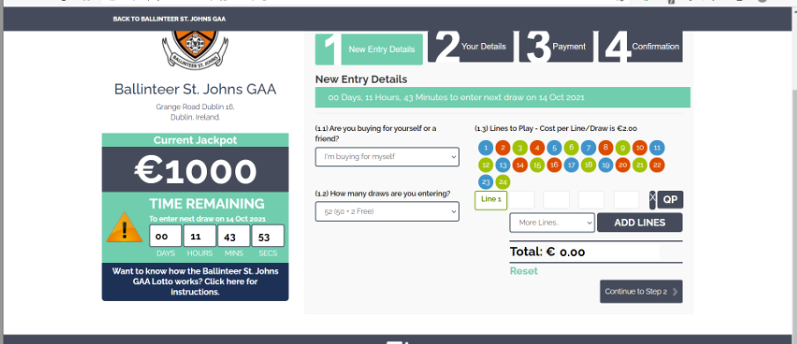
Select
- if you are buying for yourself or a friend,
- number of draws you wish to enter
- Add additional lines if you wish to by more that one line each week.
- Select 4 numbers
Then select Continue to Step 2

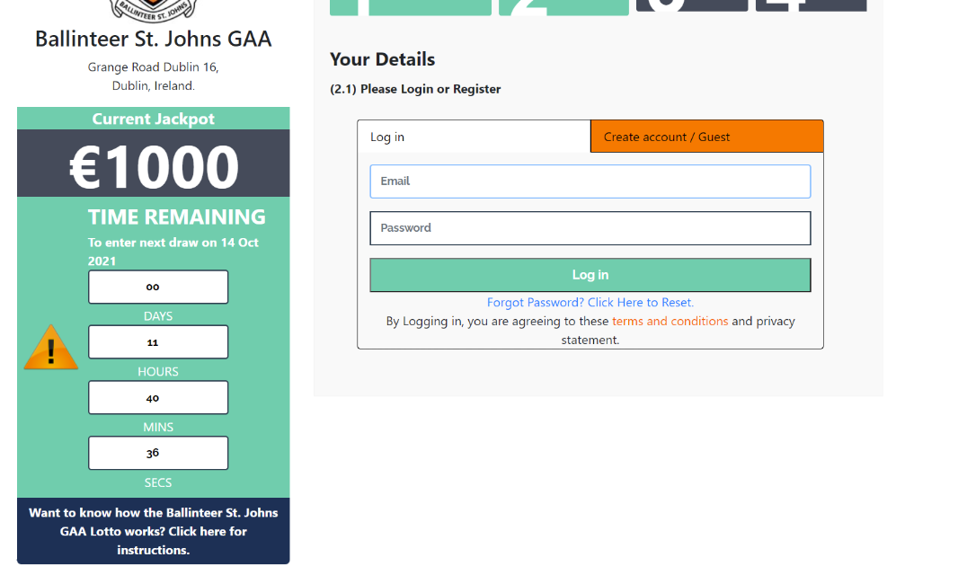

Click Create account
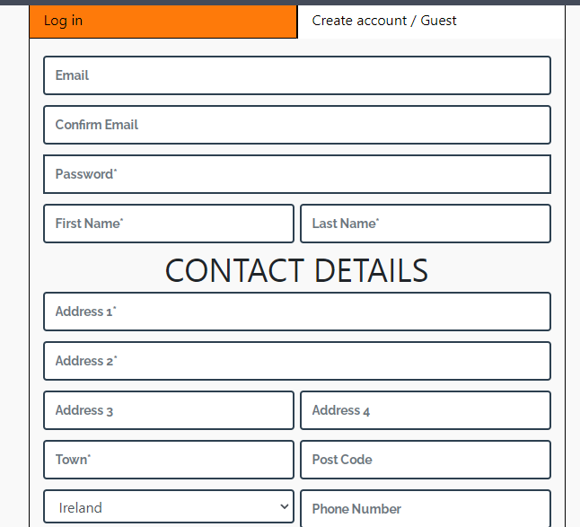
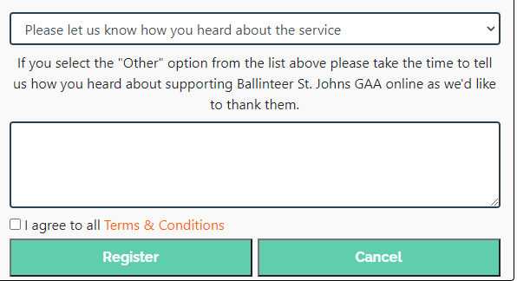
Enter your details (check and agree Term & Conditions) and Register

Payment Details

Defaults in to auto renew – this save you trying to remember to renew,
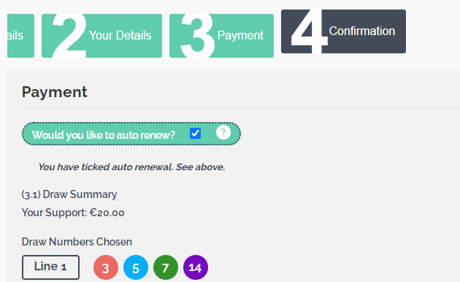
Untick if you do not wish this to occur then insert your payment information

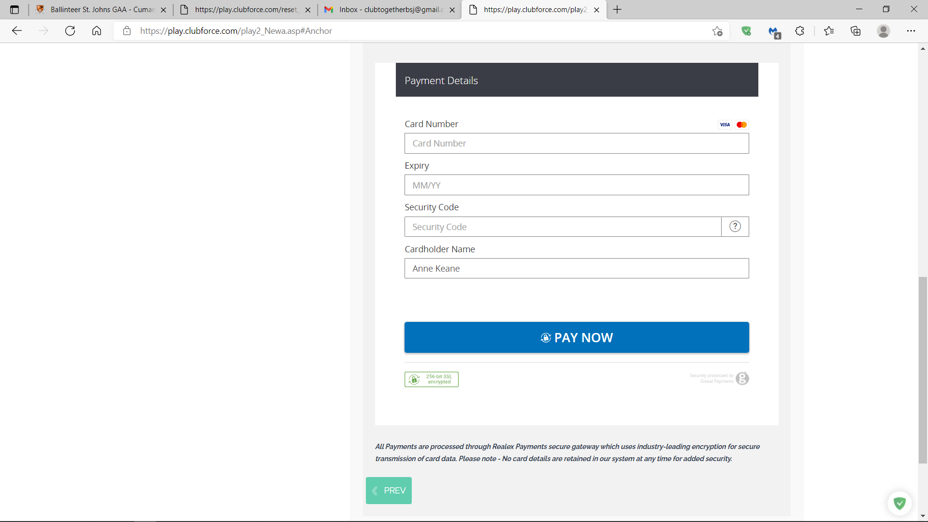

Confirmation
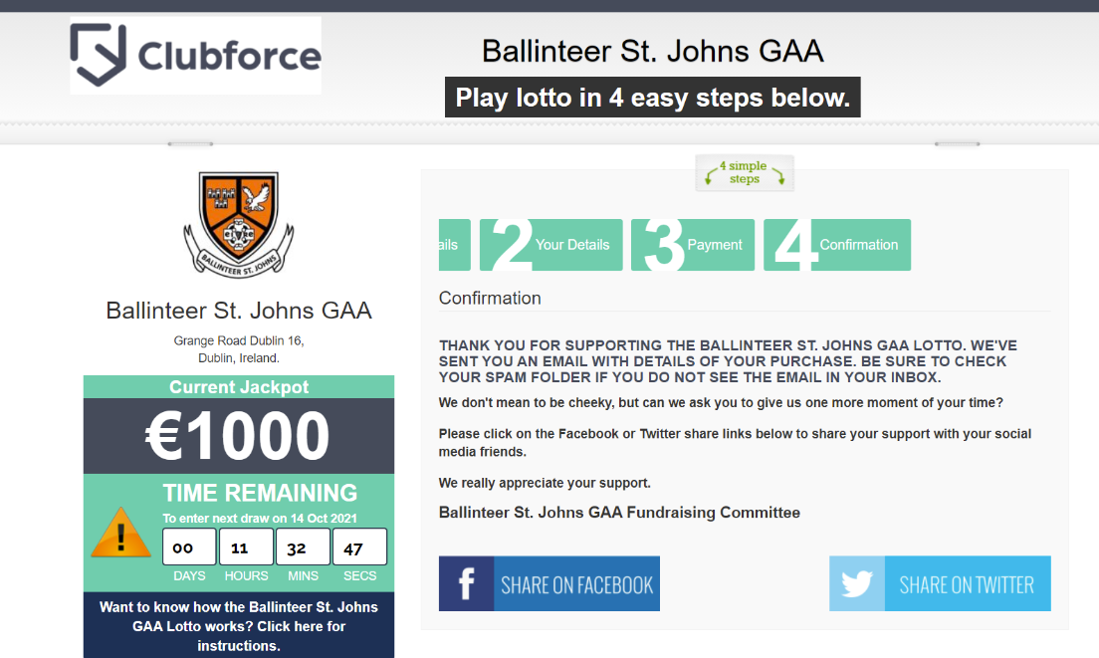

You get an email to welcome on board and you also get below on completion

